Current process
1: Run video through CV_Vehicle_tracking.py. You will get an output called detection_results.csv
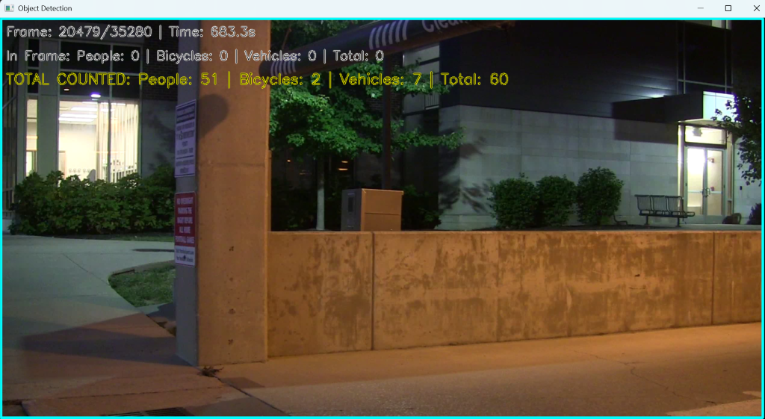
2: Run SyncVis, and sync up the detections with spikes. A CSV file is output
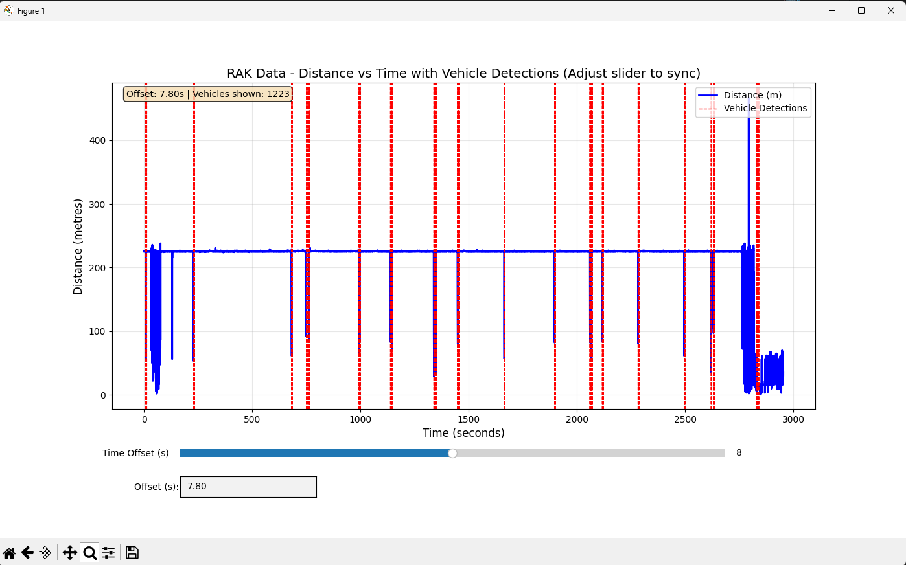

3: Analyze the data, finding characteristics that lead to detections.

